* In General, The web application and its all files will be packed and released in the form of “War” file.
* War file is jar file having extension of .war.
* We create war file for the following operations.

1. To deploy the web application in the servers.
2. To release the web application to client organization
3. To host the web application on internet.
4. To move the web application from one machine to another machine ..etc.

Example:

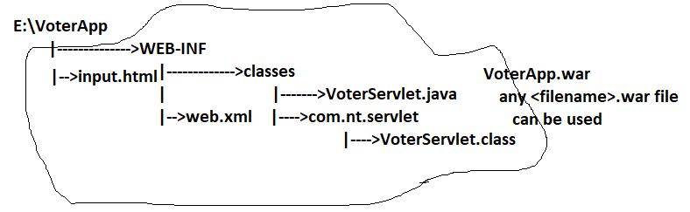

Create War file for java web application using Eclipse IDE:

===========================================

